**QUEEN MARY’S COLLEGE (A), CHENNAI 600 004.**

**DEPARTMENT OF ZOOLOGY**

The Department of Zoology conducted an induction program for the first year undergraduate Advanced Zoology and Biotechnology students on 03/07/2024. The students were welcomed by the staff. There was an ice breaking session with their tutors followed by a general instruction session with the Head of the department. They also wrote a short essay about themselves and their reason/ interest to join Queen Mary’s College. Additionally, they were given a tour of the campus.

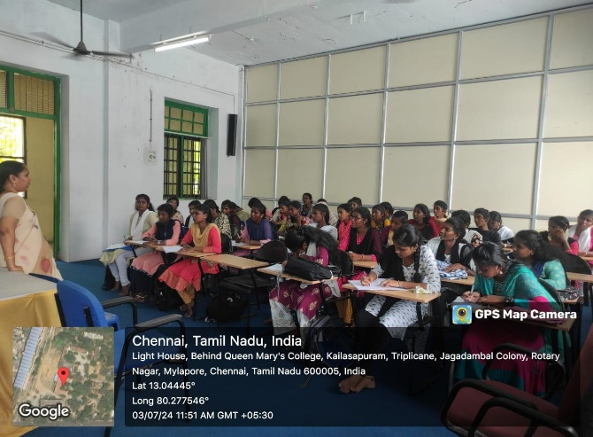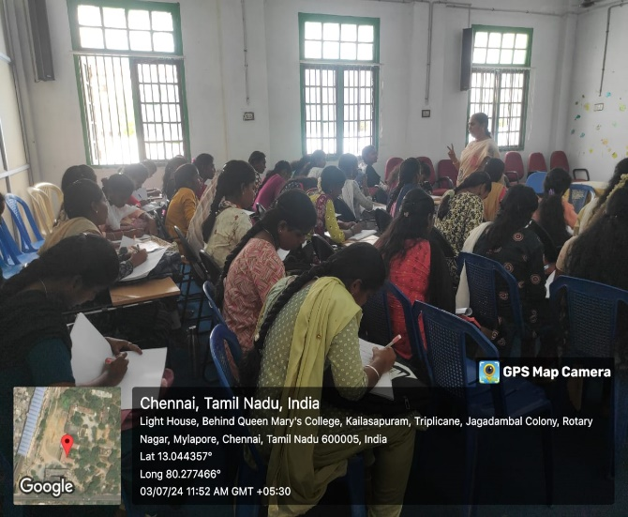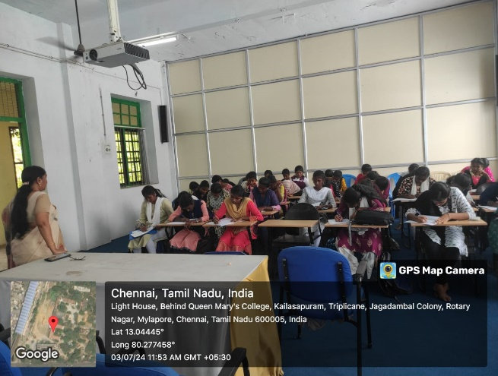

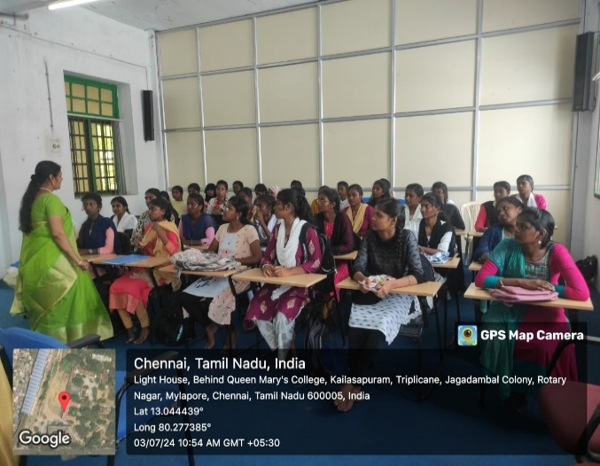

CAMPUS TOUR

