**109th Annual Sports Day Report**

**Queen Mary’s College, Chennai**

Date: 31st January 2025

The 109th Annual Sports Day of Queen Mary’s College was celebrated with great enthusiasm and fervor on January 31, 2025. The event commenced with a solemn prayer song and the college song, setting the tone for a day of sportsmanship and celebration.

**Dr. B. Umamaheshwari**, the Principal, delivered the welcome address, highlighting the significance of sports in fostering discipline, teamwork, and perseverance. This was followed by the felicitation address by **Dr. E. Uma, Associate Professor and Head of DPHS**, who emphasized the importance of physical education in holistic development.

The distinguished guests were honored, marking a moment of gratitude and appreciation. The college flag was hoisted, symbolizing the spirit of unity and sportsmanship. The sports contingents from various departments then participated in an impressive march past, displaying discipline and coordination, which was saluted by the dignitaries.

**Dr. V. Sujitha**, Head and Director of Physical Education, presented the Sports Day Report, highlighting the achievements of the college’s athletes and the various sporting events conducted throughout the year.

The highlight of the event was the Chief Guest Address delivered by **Thiru. Meganathan Reddy, IAS, Member Secretary/CEO, Sports Development Authority of Tamilnadu**

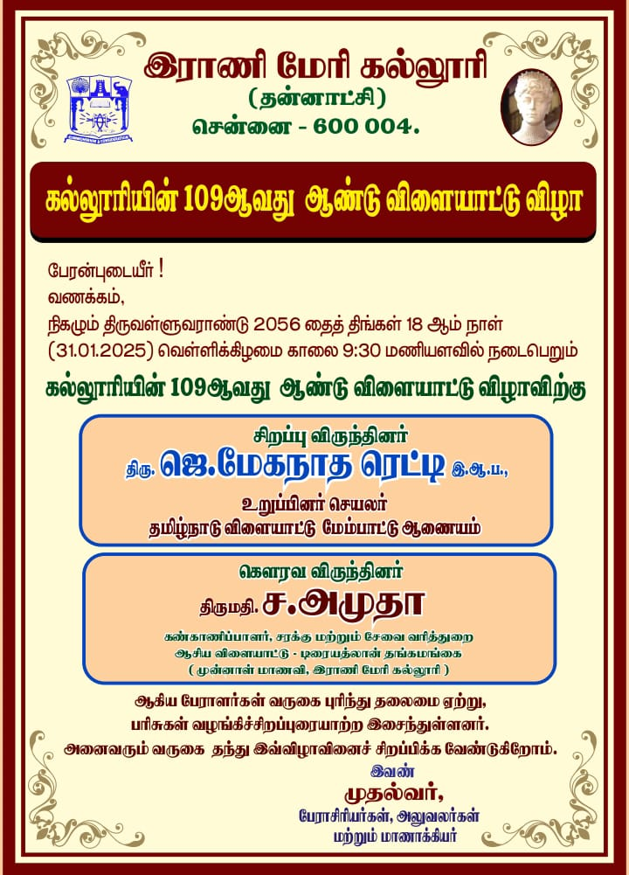

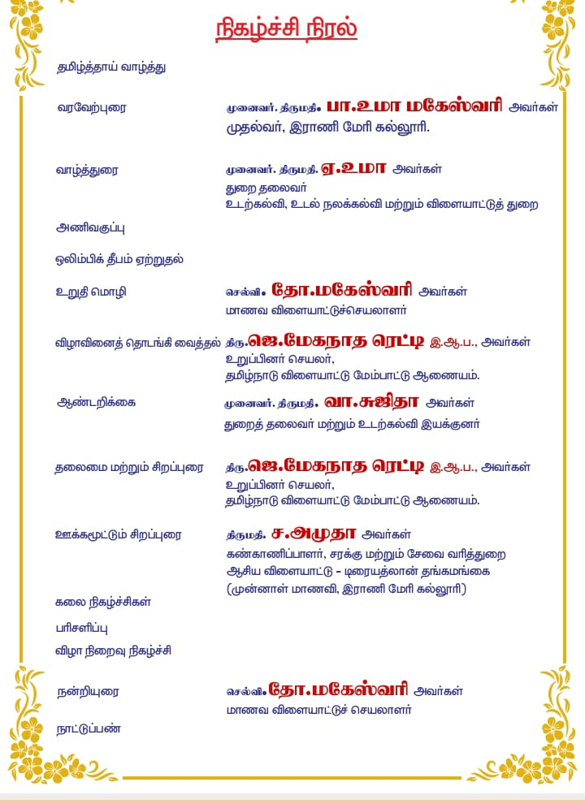

**QUEEN MARYS COLLEGE**

**Department of Physical Education, Chennai-600 004**

**Sports Day – 2024-2025**

**Department of Physical Education Health Education Sports**

|  |  |  |  |  |  |
| --- | --- | --- | --- | --- | --- |
| **KABADDI** | | | | | |
| **WINNERS** | | |  | **RUNNERS** | |
| **S.NO** | **NAME** | **CLASS** | **NAME** | **CLASS** |
|  | **K.REVATHI** | **I.B.Sc PHS** | **J.USHA** | **II.B.Sc PHS** |
|  | **K.DHARSHINI** | **I.B.Sc PHS** | **S.SWATHI** | **II.B.Sc PHS** |
|  | **M.SEVVANTHI** | **I.B.Sc PHS** | **A.SWATHI** | **II.B.Sc PHS** |
|  | **A.ABINAYA** | **I.B.Sc PHS** | **M.THIRUSELVI** | **II.B.Sc PHS** |
|  | **S.CHARULATHA** | **I.B.Sc PHS** | **R.YAMINI** | **II.B.Sc PHS** |
|  | **M.NETHRA** | **I.B.Sc PHS** | **K.SIVASANKARI** | **II.B.Sc PHS** |
|  | **T.MUNEESWARI** | **I.B.Sc PHS** | **M.GAYATHRI** | **II.B.Sc PHS** |
|  | **A,RETHIKASRI** | **I.B.Sc PHS** | **S.RESHMA** | **II.B.Sc PHS** |
|  | **S.SARUMATHY** | **I.B.Sc PHS** | **R.HARANI RAVI** | **II.B.Sc PHS** |
|  | **M.SARANYA** | **I.B.Sc PHS** | **G.GOKULAVANI** | **II.B.Sc PHS** |
|  | **R.JABA** | **I.B.Sc PHS** | **M.SAKTHIPRIYA** | **II.B.Sc PHS** |
|  | **G.GOWRI** | **I.B.Sc PHS** | **K.TAMILSELVI** | **II.B.Sc PHS** |

|  |  |  |  |  |  |
| --- | --- | --- | --- | --- | --- |
| **KHO-KHO** | | | | | |
| **WINNERS** | | |  | **RUNNERS** | |
| **S.NO** | **NAME** | **CLASS** | **NAME** | **CLASS** |
|  | **JAREENNA.A** | **II.B.Sc PHS** | **SANTHIYA MOHAN** | **III.B.Sc PHS** |
|  | **J, USHA** | **II.B.Sc PHS** | **SANDHIYA MADAN** | **III.B.Sc PHS** |
|  | **M.THIRUSELVI** | **II.B.Sc PHS** | **R.DHANUSHA** | **III.B.Sc PHS** |
|  | **K. SIVASANKARI** | **II.B.Sc PHS** | **K.DHARSHA** | **III.B.Sc PHS** |
|  | **M.SUDHARSANA** | **II.B.Sc PHS** | **P.PARKAVI** | **III.B.Sc PHS** |
|  | **B.VIJAYALAKSHMI** | **II.B.Sc PHS** | **K.ROHINI** | **III.B.Sc PHS** |
|  | **K.TAMILSELVI** | **II.B.Sc PHS** | **A.SUGANTHEESWARI** | **III.B.Sc PHS** |
|  | **G.GOKULAVANI** | **II.B.Sc PHS** | **R.SARASWATHY** | **III.B.Sc PHS** |
|  | **S.MARIAMMAL** | **II.B.Sc PHS** | **M.NANDHINI** | **III.B.Sc PHS** |
|  | **S.SWATHI** | **II.B.Sc PHS** | **S.PRITHISHA** | **III.B.Sc PHS** |
|  | **L.SOUNDHARYA** | **II.B.Sc PHS** | **T.SANTHANALAKSHMI** | **III.B.Sc PHS** |
|  | **S.SUMITHRA** | **II.B.Sc PHS** | **R.UMAMAHESWARI** | **III.B.Sc PHS** |

|  |  |  |  |  |  |
| --- | --- | --- | --- | --- | --- |
| **VOLLEYBALL** | | | | | |
| **WINNERS** | | |  | **RUNNERS** | |
| **S.NO** | **NAME** | **CLASS** | **NAME** | **CLASS** |
|  | **D.MITHRA** | **I.B.Sc PHS** | **U.ELAKIYA** | **III.B.Sc PHS** |
|  | **S.UDHAYA** | **I.B.Sc PHS** | **T.MAGESHWARI** | **III.B.Sc PHS** |
|  | **S.KAVIYA** | **I.B.Sc PHS** | **R.SOWMIYA** | **III.B.Sc PHS** |
|  | **S.CHARULATHA** | **I.B.Sc PHS** | **S.SANDHYA** | **III.B.Sc PHS** |
|  | **R.JABA** | **I.B.Sc PHS** | **J.KEERTHANA** | **III.B.Sc PHS** |
|  | **A.JAYANTHASRI** | **I.B.Sc PHS** | **A.KAVIPRIYA** | **III.B.Sc PHS** |
|  | **S.SHARUMATHI** | **I.B.Sc PHS** | **K.ROHINI** | **III.B.Sc PHS** |
|  | **V.VARSHINI** | **I.B.Sc PHS** | **R.SARASWATHY** | **III.B.Sc PHS** |
|  | **A. SATHYA** | **I.B.Sc PHS** | **A.SUGANTHEESWARI** | **III.B.Sc PHS** |
|  | **A.RETHIKA SRI** | **I.B.Sc PHS** | **G.AKSHAYA** | **III.B.Sc PHS** |
|  | **R.KALAIMATHI** | **I.B.Sc PHS** |  | **III.B.Sc PHS** |
|  | **K.DHARSHINI** | **I.B.Sc PHS** |  | **III.B.Sc PHS** |

**GENERAL**

|  |  |  |  |  |  |
| --- | --- | --- | --- | --- | --- |
| **VOLLEYBALL** | | | | | |
| **WINNERS- SOCIOLOGY** | | |  | **RUNNERS- B.COM GENERAL** | |
| **S.NO** | **NAME** | **CLASS** | **NAME** | **CLASS** |
|  | **R.POOJA PRIYA** | **III.B.A Soc** | **S.RAJADHARANI** | **II.B.COM** |
|  | **J.LOGITHA** | **III.B.A Soc** | **G.SHALINI** | **II.B.COM** |
|  | **E.DHAVASIYA** | **III.B.A Soc** | **G.M.JAMUNA** | **II.B.COM** |
|  | **M.LOKESWARI** | **III.B.A Soc** | **S.SATHYA PREETHA** | **II.B.COM** |
|  | **S.BHARATHI** | **III.B.A Soc** | **A.NISHA** | **II.B.COM** |
|  | **S.SWETHA** | **III.B.A Soc** | **B.BHAVYA** | **II.B.COM** |
|  | **S.JEBA QUEEN** | **III.B.A Soc** | **S.D.KEETHANAN** | **II.B.COM** |
|  | **A.KANCHANA** | **III.B.A Soc** | **S.AKILA** | **III.B.COM** |
|  | **M.MANVITHA** | **II.B.A Soc** | **K.KALAISELVI** | **III.B.COM** |
|  | **T. B.COM GENERAL JANANI** | **II.B.A Soc** |  |  |
|  | **S.KEERTHIKA** | **I.B.A Soc** |  |  |
|  | **AISWARIYA** | **III.B.A Soc** |  |  |

|  |  |  |  |  |  |
| --- | --- | --- | --- | --- | --- |
| **KHO-KHO** | | | | | |
| **WINNERS - B.COM GENERAL** | | |  | **RUNNERS- COMPUTER SCIENCE** | |
| **S.NO** | **NAME** | **CLASS** | **NAME** | **CLASS** |
|  | **S.YUVASHREE** |  | **S.POOJA** |  |
|  | **V,JEEVASAKTHI** |  | **S.POORNIMA** |  |
|  | **T.KARUNYAMERCY** |  | **C.JANANI** |  |
|  | **G,M,JAMUNA** |  | **A.ABILA** |  |
|  | **N.LOGESWARI** |  | **P.POONGODI** |  |
|  | **S.SRIMA** |  | **T.SIVA RANJINI** |  |
|  | **S.SHARMILA** |  | **J.SIVASANKARI** |  |
|  | **E.DEEPADHARSHINI** |  | **S.THAMAYANTHI** |  |
|  | **R.SWETHA** |  | **S.NARPAVI** |  |
|  | **G.PRIYADHARSHINI** |  | **A.MONISHA** |  |
|  | **S.SATHYAPRIYA** |  | **M.RINDHIYA** |  |
|  | **R.JEEVA** |  | **D.SHANTHINI** |  |

|  |  |  |  |  |  |
| --- | --- | --- | --- | --- | --- |
| **KABADDI** | | | | | |
| **WINNERS - TAMIL** | | |  | **RUNNERS- CHEMISTRY** | |
| **S.NO** | **NAME** | **CLASS** | **NAME** | **CLASS** |
|  | **SONA.R** | **II.M.A** | **DEEPALAKSHMI.E** | **III.B.Sc CHE** |
|  | **MONIKA CHAWALA.M** | **II.M.A** | **KALAYARASI.R** | **III.B.Sc CHE** |
|  | **SAKTHI PRIYA.S** | **II.M.A** | **BHAVANI.S** | **III.B.Sc CHE** |
|  | **SABITHA.D** | **III.BA.** | **THASLIMA.M** | **III.B.Sc CHE** |
|  | **KALAISELVI.B** | **III.BA.** | **YAMUNA.R** | **III.B.Sc CHE** |
|  | **THIRISHA.V** | **III.BA.** | **VARSHA.C** | **III.B.Sc CHE** |
|  | **MAHALAKSHMI.S** | **III.BA.** | **SELVAKUMARI.D** | **III.B.Sc CHE** |
|  | **VIVEGI.V** | **III.BA.** | **PRABAVATHI.E** | **III.B.Sc CHE** |
|  | **NANDHINI.V** | **III.BA.** | **NIVETHA.R** | **II.B.Sc CHE** |
|  | **SOPHIYA.J** | **III.BA.** | **LAVANAYA.C** | **II.B.Sc CHE** |
|  | **KASTHURI.T** | **III.BA.** | **MADHUMITHA.T** | **II.B.Sc CHE** |
|  | **KEERTHANA.R** | **III.BA.** |  |  |

|  |  |  |  |  |  |
| --- | --- | --- | --- | --- | --- |
| **TABLE TENNIS** | | | | | |
| **WINNERS-HISTORY** | | |  | **RUNNERS- COUMPUTER SCIENCE** | |
| **S.NO** | **NAME** | **CLASS** | **NAME** | **CLASS** |
|  | **P.DHANALAKSHMI** | **I.B.A** | **D.VISHNUPRIYA** | **III.B.Sc** |
|  | **K.NANDHINI** | **I.B.A** | **T.HARSHINI** | **III.B.Sc** |

|  |  |  |  |  |  |
| --- | --- | --- | --- | --- | --- |
| **CARROM** | | | | | |
| **WINNERS-SOCIOLOGY** | | |  | **RUNNERS- B.COM GENERAL** | |
| **S.NO** | **NAME** | **CLASS** | **NAME** | **CLASS** |
|  | **S.AUGUSTINA** | **III.B.Sc** | **L.JAMUNA** |  |
|  | **M.MONIKA** | **III.B.Sc** | **G.SHALANI** |  |

|  |  |  |  |  |  |
| --- | --- | --- | --- | --- | --- |
| **CHESS** | | | | | |
| **WINNERS- B.COM (C.S)** | | |  | **RUNNERS- HISTROY** | |
| **S.NO** | **NAME** | **CLASS** | **NAME** | **CLASS** |
|  | **A.SRIDEVI** | **IIIB.COM C.S** | **S.PREETHI** | **III.B.A** |

**GENERAL**

|  |  |  |
| --- | --- | --- |
| **100 M** | | |
| **Place** | **NAME** | **CLASS** |
| **First** | **S.SUBASAKTHI** | **I.B.COM CS** |
| **Second** | **ABILA.A** | **I B.SC C.S** |
| **Third** | **KEERTHIGA.P** | **III.B.SC CHE** |

|  |  |  |
| --- | --- | --- |
| **400 M** | | |
| **Place** | **NAME** | **CLASS** |
| **First** | **T.SIVARAJANI** | **I.B.SC C.S** |
| **Second** | **K.SWETHA** | **I.B.A TAMIL** |
| **Third** | **R.SWATHI** | **III.B.COM** |

|  |  |  |
| --- | --- | --- |
| **1500 M** | | |
| **Place** | **NAME** | **CLASS** |
| **First** | **SELVAM** | **M.SC CHE** |
| **Second** | **JEBAQUEEN** | **III.B.A SOC** |
| **Third** | **SUWATHI** | **II.B.A.ECO** |

|  |  |  |
| --- | --- | --- |
| **SHOT-PUT** | | |
| **Place** | **NAME** | **CLASS** |
| **First** | **DHEIVANAYAKI.S** | **III.B.A(HIS)** |
| **Second** | **AKILA.S** | **III.B.COM SHIFT-2** |
| **Third** | **VISHNUPRIYA.D** | **I.B.Sc (C.S)** |

|  |  |  |
| --- | --- | --- |
| **DISCUS** | | |
| **Place** | **NAME** | **CLASS** |
| **First** | **D.VISHNU PRIYA** | **I.B.Sc (C.S)** |
| **Second** | **R.JEEVA** | **II.B.COM** |
| **Third** | **DHEIVANAYAKI.S** | **III.B.A(HIS)** |

|  |  |  |
| --- | --- | --- |
| **4X100 M RELAY** | | |
| **Place** | **NAME** |  |
| **First** | **KEERTHIGA.P** | **Chemistry** |
| **PARAVATHI.E** |
| **USHA RANI.A** |
| **SELVAM.R** |
| **Second** | **ANGELMARY M** | **B.COM C.S** |
| **SRIVIDHYA C** |
| **SINDUJA.A** |
| **SUBASAKTHI.S** |
| **Third** | **ABILLA.A** | **COMPUTER SCIENCE** |
| **VELJAYANTHI.S** |
| **MONISHA.A** |
| **POOJA.S** |

**VISUALLY CHALLENGED**

|  |  |  |
| --- | --- | --- |
| **50 M** | | |
| **Place** | **NAME** | **CLASS** |
| **First** | **SUBALAKSHMI M** | **II.B.A HIS** |
| **Second** | **MAHALAKSHMI.M** | **II.B.A HIS** |
| **Third** | **KEERTHANA.R** | **II.B.A HIS** |

**PARTIALLY BLIND**

|  |  |  |
| --- | --- | --- |
| **50 M** | | |
| **Place** | **NAME** | **CLASS** |
| **First** | **T.MALATHI** | **I.B.A TAMIL** |
| **Second** | **K.KAMALISHA** | **I.B.A ENG** |
| **Third** | **G.MITHUNA** | **II.B.A.HIS** |

|  |  |  |
| --- | --- | --- |
| **BALL THROW** | | |
| **Place** | **NAME** | **CLASS** |
| **First** | **T.MALATHI** | **I.B.A TAMIL** |
| **Second** | **G.MITHUNA** | **II.B.A.HIS** |
| **Third** | **MAHALAKSHMI.M** | **II.B.A HIS** |

|  |  |  |
| --- | --- | --- |
| **BROAD JUMP** | | |
| **Place** | **NAME** | **CLASS** |
| **First** | **T.MALATHI** | **I.B.A TAMIL** |
| **Second** | **P.SUBASHINI** | **III B.A.HIS** |
| **Third** | **D.SUNITHA** | **II.B.A. ENG** |

**Department of Physical Education Health Education Sports**

|  |  |  |
| --- | --- | --- |
| **200 M** | | |
| **Place** | **NAME** | **CLASS** |
| **First** | **A.KAVIPRIYA** | **III.B.Sc PHS** |
| **Second** | **MOULIKA.M** | **III.B.Sc PHS** |
| **Third** | **B.VIJAYALAKSHMI** | **II.B.Sc PHS** |

|  |  |  |
| --- | --- | --- |
| **800 M** | | |
| **Place** | **NAME** | **CLASS** |
| **First** | **A.SUGNATHEESWARI** | **III.B.Sc PHS** |
| **Second** | **S.PRITISHA** | **III.B.Sc PHS** |
| **Third** | **S.KAVIYA** | **I.B.Sc PHS** |

|  |  |  |
| --- | --- | --- |
| **5000 M** | | |
| **Place** | **NAME** | **CLASS** |
| **First** | **K.KAYALVIZHI** | **II.B.Sc PHS** |
| **Second** | **V.VARHINI** | **I.B.Sc PHS** |
| **Third** | **MOULIKA.M** | **II.B.Sc PHS** |

|  |  |  |
| --- | --- | --- |
| **SHOT-PUT** | | |
| **Place** | **NAME** | **CLASS** |
| **First** | **R.KALAIMATHI** | **I.B.Sc** |
| **Second** | **G.ARUCHANA** | **II.B.SC** |
| **Third** | **S.LOGITHA** | **III.B.SC** |

|  |  |  |
| --- | --- | --- |
| **JAVELIN** | | |
| **Place** | **NAME** | **CLASS** |
| **First** | **R.KALAIMATHI** | **I.B.Sc PHS** |
| **Second** | **U.ELAKIYA** | **III.B.SC PHS** |
| **Third** | **V.DILLEESWARI** | **I.B.SC PHS** |

|  |  |  |
| --- | --- | --- |
| **4X400 RELAY** | | |
| **Place** | **NAME** | **CLASS** |
| **First** | **K.KAYALVIZHI** | **II.B.SC PHS** |
| **JAREENA** |
| **USHA** |
| **L.SOUNDHARYA** |
| **Second** | **V.DILLEESWARI** | **I.B.SC PHS** |
| **M.ANISHA** |
| **S.SARUMATHY** |
| **V.VARSHINI** |

**TEACHING STAFF**

|  |  |  |
| --- | --- | --- |
| **SHOT-PUT 30-40 AGE** | | |
| **Place** | **NAME** | **DEP** |
| **First** | **DR.A.SAKTHI PRIYA** | **ENGLISH** |
| **Second** | **R.SUREKA** | **BCA** |
| **Third** | **N.KOKILA** | **ENGLISH** |

|  |  |  |
| --- | --- | --- |
| **SHOT-PUT 41-50 AGE** | | |
| **Place** | **NAME** | **DEP** |
| **First** | **.M.PREMALATHA** | **CHEMISTRY** |
| **Second** | **I.G.ARUNA** | **ENGLISH** |
| **Third** | **P.M.VAUGI** | **ENGLISH** |

|  |  |  |
| --- | --- | --- |
| **SHOT-PUT 51-60 AGE** | | |
| **Place** | **NAME** | **DEP** |
| **First** | **G.SADHANA** | **ENGLISH** |
| **Second** | **JAYALAKSHMI** | **PHYSICS** |
| **Third** | **M.MEGALADEVI** | **ENGLISH** |

|  |  |  |
| --- | --- | --- |
| **100M 30-40 AGE** | | |
| **Place** | **NAME** | **DEP** |
| **First** | **R.SUREKA** | **BCA** |
| **Second** | **N.SITHI ZEENATH NISHA** | **TAMIL** |
| **Third** | **A.SAKTHI PRIYA** | **ENGLISH** |

|  |  |  |
| --- | --- | --- |
| **100M 41-50 AGE** | | |
| **Place** | **NAME** | **DEP** |
| **First** | **JAYANTHI.K** |  |
| **Second** | **.M.PREMALATHA** | **CHEMISTRY** |
| **Third** | **P.M.VAUGI** | **ENGLISH** |

|  |  |  |
| --- | --- | --- |
| **100M 50-60 AGE** | | |
| **Place** | **NAME** | **DEP** |
| **First** | **JAYALAKSHMI** |  |
| **Second** | **P.JAYANTHI** |  |
| **Third** | **BAKIYALAKSHMI** |  |

|  |  |  |
| --- | --- | --- |
| **CARROM** | | |
| **Place** | **NAME** | **DEP** |
| **First** | **M.PREMALATHA**  **K.BHARATHI** | **CHEMISTRY** |
| **Second** | **K.GEETHA**  **R,SUMITRA** | **MATHS** |

|  |  |  |
| --- | --- | --- |
| **BADMINTON** | | |
| **Place** | **NAME** | **DEP** |
| **First** | **M.PREMALATHA** | **CHEMISTRY** |
| **Second** | **K.BHARATHI** | **CHEMISTRY** |

|  |  |  |
| --- | --- | --- |
| **CHESS** | | |
| **Place** | **NAME** | **DEP** |
| **First** | **R.HEMAVATHY** | **MATHS** |
| **Second** | **M.PREMALATHA** | **CHEMISTRY** |

|  |  |  |
| --- | --- | --- |
| **THROWBALL** | | |
| **S.NO** | **WINNERS** | **RUNNERS** |
|  | **SADHANA** | **E UMA** |
|  | **P.M. VASUGI** | **ARUNA** |
|  | **K. JAYANTHI** | **A. SAKTHIPRIYA** |
|  | **I.G. ARUNA** | **K. BHARATHI** |
|  | **N. KOILA** | **R. HEMAVATHY** |
|  | **VIJAYALAKSHMI** | **JAYALAKSHMI** |
|  | **BAKYALAKSHMI** | **JAYANTHI.K** |
|  | **PUNITHA** | **M.PRENALATHA** |
|  | **T. BHUVANESWARI** | **V.VIDHYA** |
|  | **N. SITHI ZEENATH NISHA** | **R. SUREKHA** |

**Staff Overall winner Chemistry Department**

