QUEEN MARYS COLLEGE (AUTONOMOUS)
DEPARTMENT OF HOME SCIENCE
ANNUAL REPORT 2022-2023
The field of Home Science is multi faceted and serves as a framework for many specialized courses that offer a broad spectrum of job opportunities. The department strives to equip the students with knowledge and hands on experiences thereby enabling them to surge forward in their careers. In this context a wide range of activities are conducted throughout the year. Enhancement of public health and community nutrition is the core objective of the department and the activities for this academic year began with propagating the importance of exclusive breast feeding. On 3rd August 2022 a series of competitions were organised under the general theme “MazhalayinAmudhu… UyirinVizhuthu…” Students from all departments in the college vied with one another to showcase their talents in the Poster, Recipe, Flipbook Animation, Haikukavithai and Mime Competitions. The prizes and certificates were sponsored by Indian Dietetic Association and distributed by Mr. Krishnamurthy, convenor, IDA Chennai chapter.

The World breastfeeding week was celebrated from 1st to 7th August 2022, to promote breastfeeding. The theme this year is "Step up for breastfeeding: educate and support". An awareness program for pregnant and lactating mothers residing in Tondiarpet was conducted on 3rd August 2022, at Chennai Corporation School, Tondiarpet in association with IFTE - Various charts were prepared and displayed on the importance of breast milk, myths and facts, nutritive value, feeding problem and solution, feeding position, breast milk storage, and breast milk bank. The concepts were also conveyed through puppet show with song enactment, skit, street play and an exhibition on low cost lactogogue recipes.

Skill development is a salient feature of the curriculum and a work shop on Kashmiri Carpet Embroidery work was conducted for the second year UG students by an artist Balkishan. The professors Mrs.Vijayapriya and Ms.Prasanna of Home Science Department assisted the students with the work.

Successful self employment and development of entrepreneurial skills is the top priority of the department. In this context an International Workshop on Food Product Development in association with NSI Chennai chapter and TNSCT was organized to commemorate National Nutrition month celebration on 16th and 17th September 2022.The Principal of Queen Mary’s College Dr.B.Uma Maheswari in her presidential address outlined the crucial steps involved in product development. Chief guest Mr.Jambunathan Ilango, advocate and vice president of Indian ASEAN Chamber of Commerce, Sri Lanka, detailed the evolution of food product development right from the stage of agriculture and farming to marketing of the product.
Due to space constraints a bird’s eye view of the programme is presented as follows - Nine eminent speakers and subject experts addressed the students on current trends in food product development incorporating millets, dairy products and pazhaya sadham. A mesmerising session on use of food as medicine (Nutripathy) was well appreciated by students. The use of microbes and sea weeds in food product development enthralled the audience. Students gained knowledge on methods of standardization and sensory analysis of newly developed food products. Students were motivated by sessions on entrepreneurship and innovative food product development. They also gained an insight about sustainable food packaging. A competition on food product development was conducted and students came up with fascinating food products.
Strengthening the moral values and ethics of the students along with career guidance is also focused upon and an orientation programme was conducted on 10th October 2022 for the first UG and PG students. Dr.K.Kasthuri, Associate Professor made an interesting and useful power point presentation.
Extension activities are carried out every year to develop the communication skills of the students in disseminating knowledge. In line with this a nutrition education programme on adolescent nutrition was conducted for the hostel students of Queen Mary’s College on 13th October 2022. The programme was planned and organized by Dr.K.Kasthuri, Associate Professor and Mrs.S.PrasannaDevi, Guest Faculty, Department of Home Science, Queen Mary’s College, Chennai along with II PG students.
The III rd year UG students carried out an extension activity on 13th October 2022 for SSL school children in Queen Mary's campus. The activity aimed to create awareness on healthy eating habits and nutrition during childhood. The health and nutrition messages were disseminated to the children through folk song, puppet show, fashion show, dance, riddles and many interesting games.
In connection with the International Year of Millets 2023, a series of competitions were organized to propagate the goodness of millets for health. The event entitled “Millets Consumption for Good health” included recipe, poster, slogan and health card contests among students in the Department of Home Science on 10th November 2022. The International Year of Millet 2023 was emphatically narrated by Dr.K.Kasthuri, Associate Professor of Home Science. The prizes were sponsored by Bank of Baroda.
The PG and UG students held an exhibition at the trade fair on 7th and 8th January 2023. The students displayed different recipes made from millets to encourage the consumption of millets and highlight the importance of millets in a healthy diet. In addition students presented a skit on Cereals vs. Millets to demonstrate the advantages of consuming millets and video presentation on preparation of a variety of recipes using millets. Many interesting games were conducted to engage the visiting public of all age groups.

In commemoration of the International Year of Millets 2023 an awareness campaign on the Importance of Millets in the Diet was organized through a walkathon along the shores of the Marina on 21st January 2023.The event was flagged off by Dr.Uma Manohar, Associate professor and Head, Department of Physical Education, Health Education and sports at 7.45 a.m. opposite to Vivekananda Illam.
In order to showcase and fine tune the innate skills of the students various competitions such as flower arrangement, poster and debate were conducted by Dr.K.Kasthuri, Associate Professor, on 24th January 2023 at Queen Mary's College. Innovative themes were selected for each competition. This is a regular feature of the Home science association activities.
The department also organized two lectures as part of the association activity on 25th January 2023. The first lecture by Mr. P. Krishnamurthy, President IDA, Chennai chapter, and Senior Consultant Dietician, Venkateswara Hospitals dealt with Nutritional Management of the Critically Ill patients.The next Lecture on upholding values in life was a mesmerizing session by Mr. Sridhar Ranganathan, CEO and Co-founder Helyxon Healthcare Solutions. The talk titled Varisu- Thunivu names of recent blockbusters, caught the attention of all instantaneously. The speaker humorously inspired the students to reflect on their position in life while motivating them to aim for the highest.
In Connection with International year of millet celebration 2023 - I’m Milletian Campaign, E-Poster Competition was planned for the month February 2023. The theme was “Mighty Millets in Holistic Health". Around 61 students participated from various colleges in the state.

The highlight of the academic year was the Food Safety Management System Internal Auditor Training Programme – FSMS and FSSC. In collaboration with LGPS Professional Services, New Delhi and AFSTI Chennai chapter a three day workshop (23rd, 24th and 25th February 2023)was conducted on Food Safety Management System -Internal Auditor Training programme followed by internal auditor qualifying examination on 27th February 2023. Mr. Ravi Uppin - Lead Auditor for ISO Standards (FSMS, FSSC, QMS, OHASS, EMS), Chief consultant from LG Professional Service Pvt Ltd, New Delhi conducted the sessions on ISO 22000, 22002 series standards on the first two days. The training session on day three of the workshop was given by Mrs.Keerthi D’souza Managing Director and Lead Auditor for ISO Standards (FSMS, FSSC, QMS, OHASS, EMS), LG Professional Service Pvt Ltd, New Delhi.This serves as an excellent platform for aspiring students to be employed as food safety auditors in catering and food industries.

This being the International Year of Millets, the Department of Home Science, Queen Mary’s College and Millet Leaf (a Start-up Co) jointly organized an awareness campaign on the Importance of Millets in the Diet through a recipe competition titled Millet Munch on 1st March 2023. The inaugural address was given by Principal Dr.B.Uma Maheshwari who highlighted the importance of millets in this modern age. The celebrity judges Mrs. Krishnakumari Jeyakumar and Ms.Revathi Shanmugam evaluated the recipes and addressed the student. 52 students participated from various colleges in the city. The programme was sponsored by Leo Sait Agros, a startup company dealing with organic food products.

The final event for this academic year was the icing on the cake. A webinar on Genesis and action plan for observance of International year of Millet 2023 was organized on 8th April 2023. The eminent guest speaker was Dr. Suresh Malhothra, Director ICAR , New Delhi. We had the opportunity to hear the very voice of India that proposed the International year of Millet. The webinar showcased the brilliance of the speaker as he took us through the journey of Millets towards holistic health and sustainable food crop production. This webinar was hosted on YouTube in order to reach out to a wider audience.

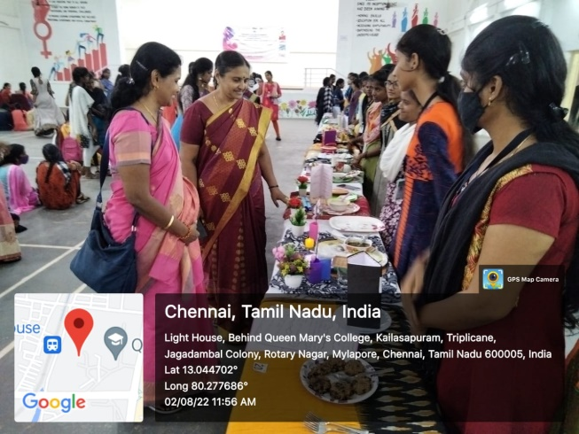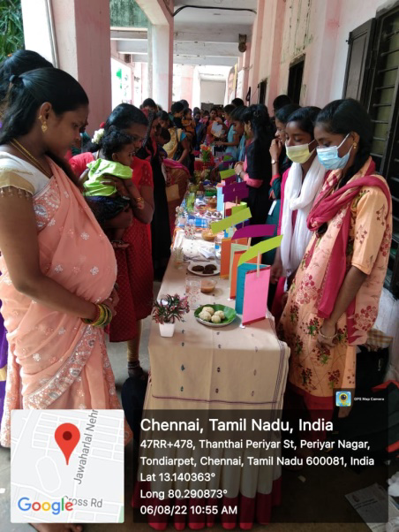
Students creating breast feeding awareness for pregnant and lactating mothers residing in Tondiarpet through low cost lactogogue recipes

Principal viewing Mazhalaiyin Amudhu…
Uyirin Vizhuthu Contest Recipes

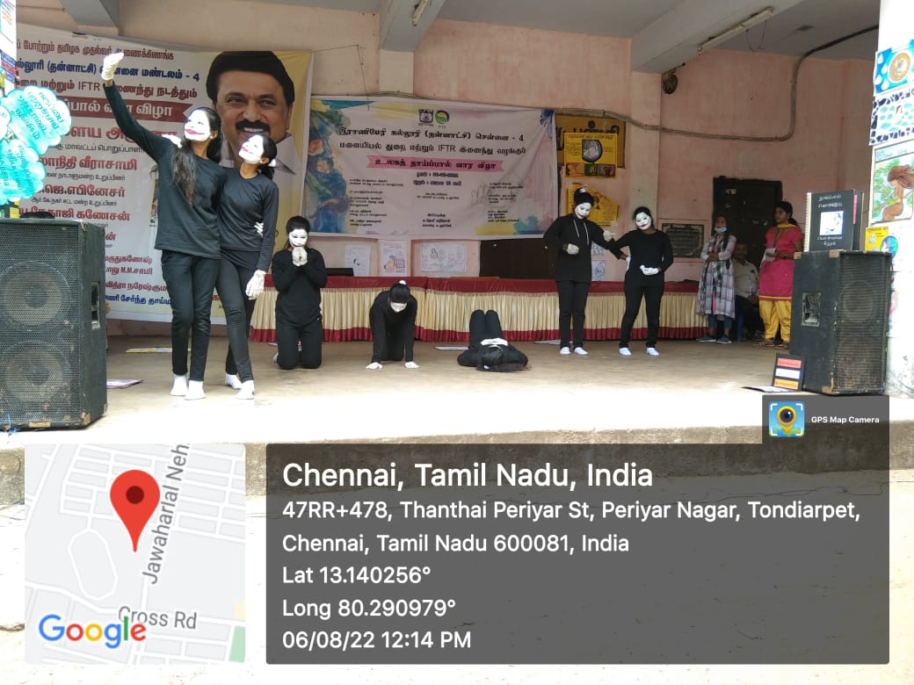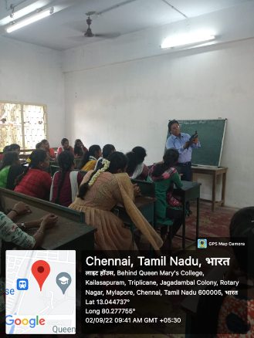
Students creating breast feeding awareness for pregnant and lactating mothers residing in Tondiarpet through various activities.
Artist Balkishan explaining Kashmiri Carpet Embroidery work to students

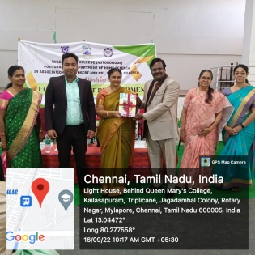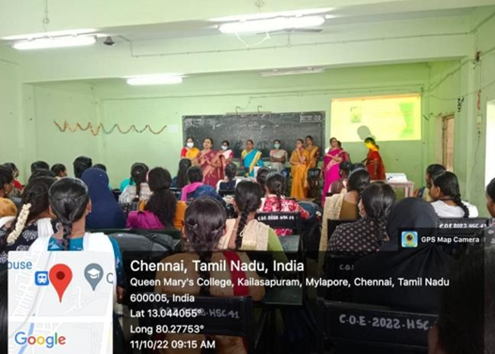
Orientation programme 2022
Principal felicitating chief guests of International Workshop on Food Product Development

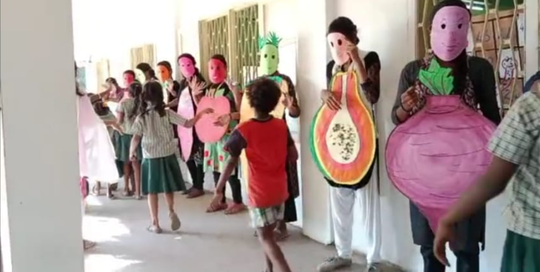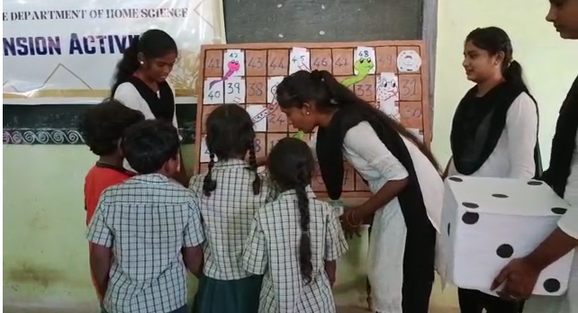
Students creating awareness on healthy eating habits and nutrition to SSL School Children through various activities

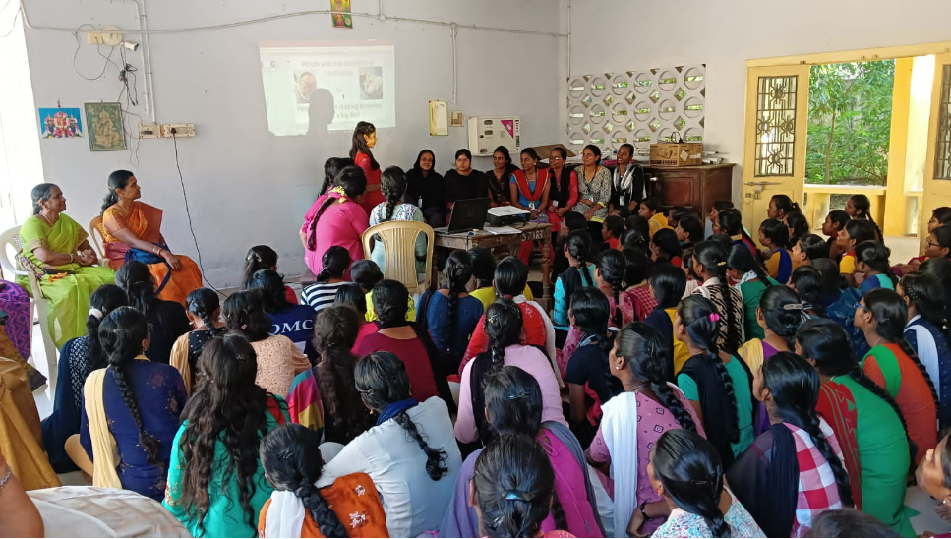
Nutrition Education Programme for Queen Mary’s College Hostel Students

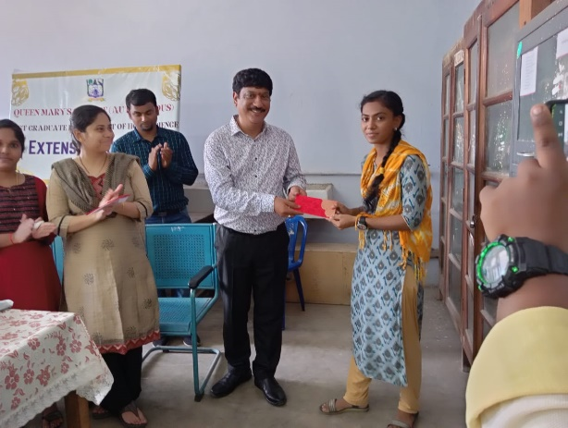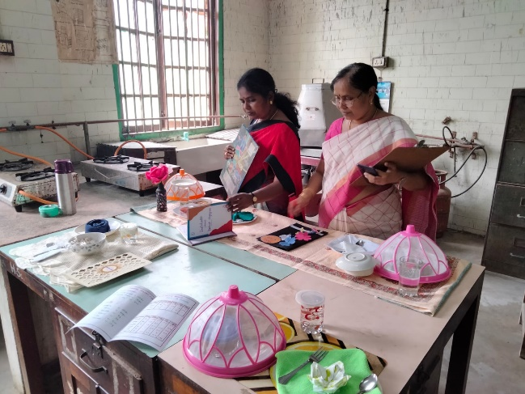
International Year of Millet contests in association with Bank of Baroda

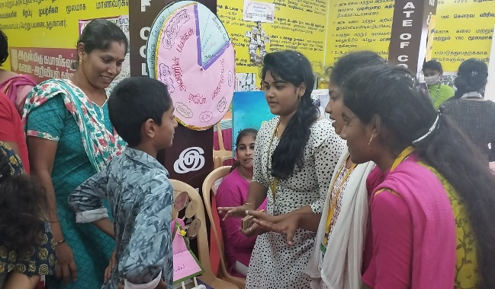
Trade fair Exhibition 2023

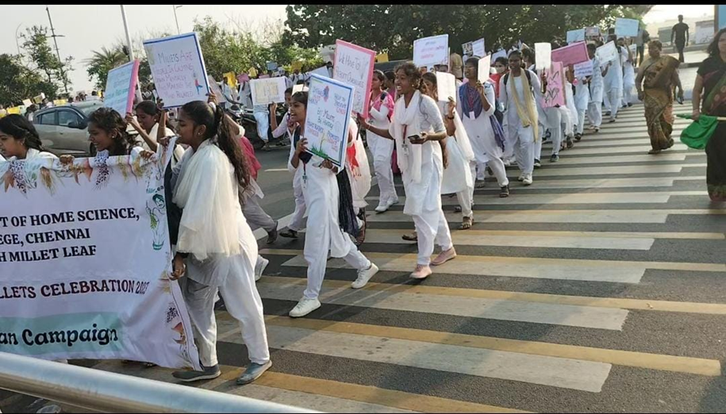
I’m MILLETian Campaign - Walkathon 2023
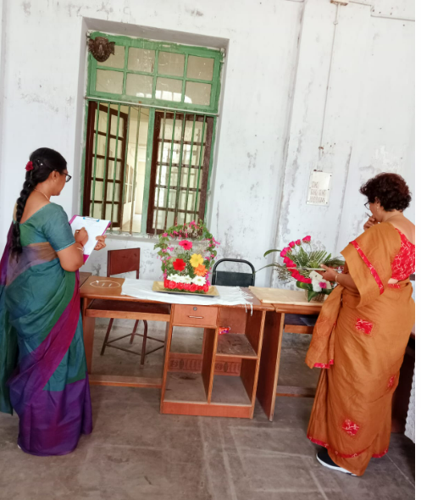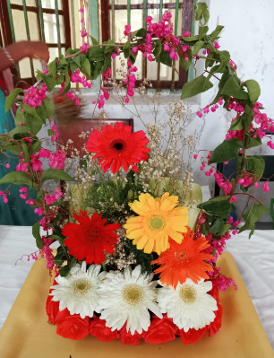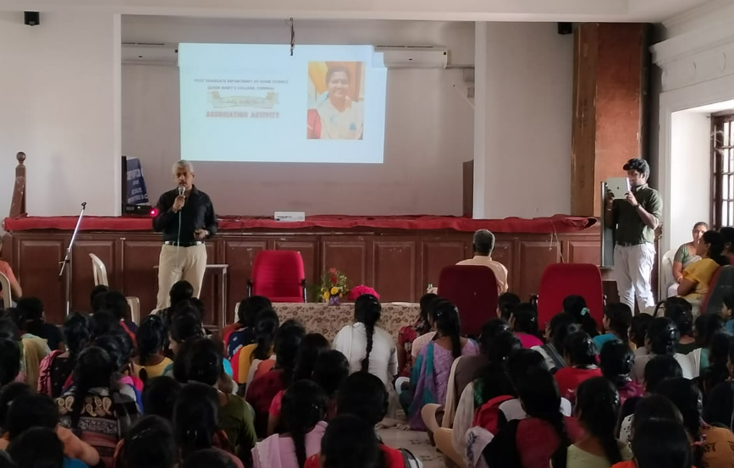
Home Science Association Activities 2022-2023

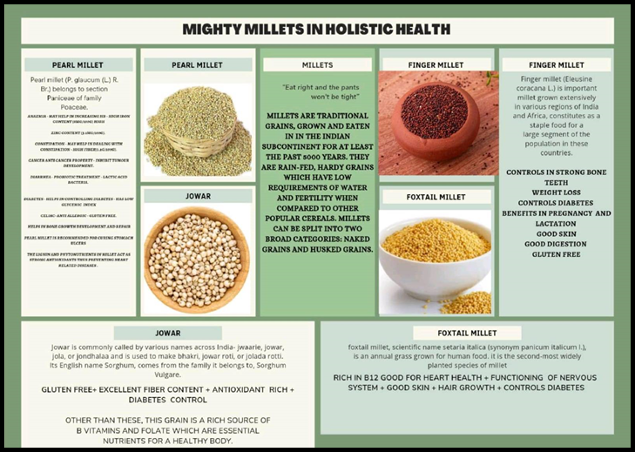
I’m Milletian Campaign, E-Poster Competition- Prize Winning Poster
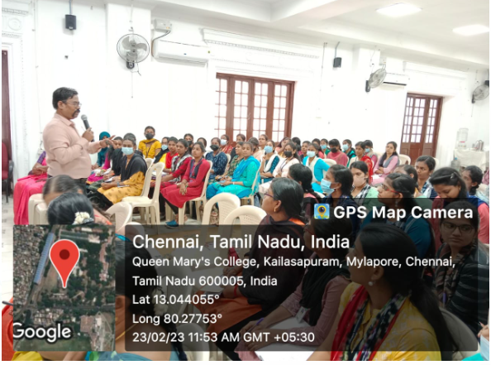
Food Safety Management System Internal Auditor Training Programme – FSMS and FSSC

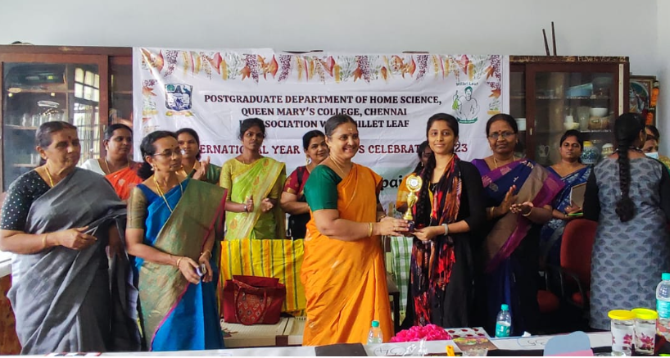
I’m MILLETian Campaign - Millet Munch

